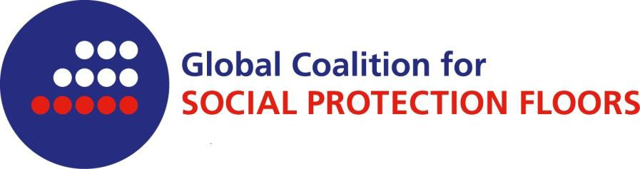

The Global Coalition for Social Protection Floors was created in summer 2012.

Membership is open to NGOs that are representatives of their constituencies and that agree to the Coalition’s principles and aims.

The Coalition operates within a worldwide network structure without formal headquarter, secretariat and sponsorship department. The coalition will communicate with ILO, the UN Inter Agency Board on the SPF and other relevant organizations as well as contribute to international and regional forums.

To join the Global Coalition for Social Protection Floors

I hereby declare that the civil society organization
(name of the organization)
would like to join the worldwide network of the Global Coalition for Social Protection Floors.
The before mentioned organization is committed to the Global Coalition’s aims.

Its contact details are as follows:

Physical address of headquarter:
Telephone number:
E-mail:
Homepage:

Global Coalition’s contact person in the above mentioned organization:

As a member of the Global Coalition information will be sent to the given email address.

(place, date) |  | signature

The Global Coalition for Social Protection Floors has four major aims:

- to seek to influence international debates on a social protection floor and raise awareness of the ILO Recommendation, based on the joint statement presented to the 101st International Labour Conference (particularly relating to the post-2015 MDGs agenda);
- to create a platform for learning experiences among civil society organizations worldwide, including contributing to the development of tools;
- to collaborate with national and regional social protection platforms and/or coalitions, where these exist, particularly those whose efforts seek to promote uptake of SPF objectives; and,
- to advocate for the formation of inclusive coalitions, where these do not exist, aimed at promoting the design, implementation, monitoring and evaluation of social protection floors.

The Coalition is committed to:

- a philosophy of inclusiveness, availability, non-discrimination and mutual respect;
- a collective output: and,
- solidarity in negotiating positions.

The coalition further encourages active involvement of all its members, and will be independent of governments and transparent in the way it does business.

APPENDIX: The list of members of the Global Coalition for Social Protection Floors is available here.

