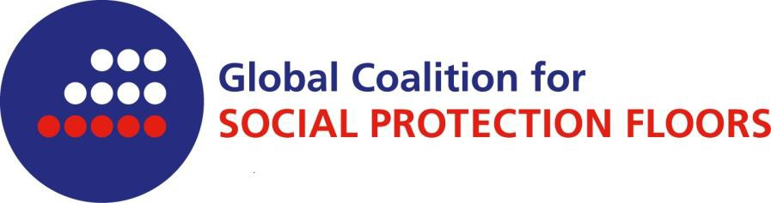

The Global Coalition for Social Protection Floors was created in summer 2012.

Membership is open to NGOs that are representatives of their constituencies and that agree to the Coalition’s principles and aims.

The Coalition operates within a worldwide network structure without formal headquarter, secretariat and sponsorship department. The coalition will communicate with ILO, the UN Inter Agency Board on the SPF and other relevant organizations as well as contribute to international and regional forums.

To join the Global Coalition for Social Protection Floors

I hereby declare that the civil society organization
(name of the organization)
would like to join the worldwide network of the Global Coalition for Social Protection Floors.
The before mentioned organization is committed to the Global Coalition’s aims.

Its contact details are as follows:

Physical address of headquarter:
Telephone number:
E-mail:
Homepage:

Global Coalition’s contact person in the above mentioned organization:

As a member of the Global Coalition information will be sent to the given email address.

(place, date) |  | signature

The Global Coalition for Social Protection Floors has five major goals:

- Strategically influence and have dialogue with the United Nations, Specialized Agencies, Member States and civil society working within the remit of various intergovernmental organs to encourage debate and positive action on human rights-based social protection floors and social protection systems through collective actions;
- Coordinate initiatives and activities at all levels, national, regional and international, enhancing the effectiveness of collective political strategy aimed at universal human rights-based social protections floors and social protection;
- Foster the formation of and cooperation between inclusive national and regional coalitions aimed at promoting the design, implementation, monitoring and evaluation of human rights-based social protection floors and social protections systems;
- Raise the visibility of research by civil society organizations promoting inclusive, rights-based social protection floors and social protection systems to inform national and global policy discussions; and
- Strengthen collaboration between NGOs , other civil society organizations, trade unions and other stakeholders to promote human rights-based social protection floors and social protection systems by creating a platform for learning experience and exchanges.

The coalition further encourages active involvement of all its members, and will be independent of governments and transparent in the way it does business.

APPENDIX: The list of members of the Global Coalition for Social Protection Floors is available here.

