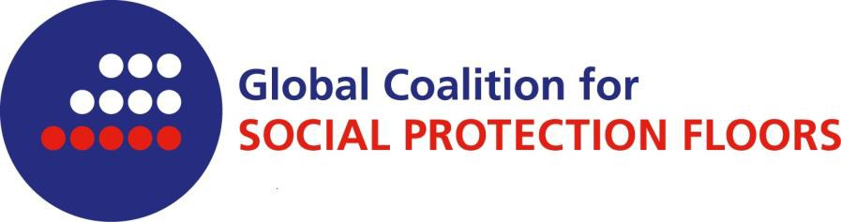

The Global Coalition for Social Protection Floors (GCSPF) was constituted in June 2012 by NGOs, other CSOs and Trade Unions to promote the implementation of Recommendation 202, as it is a key tool to achieve universal provision of economic and social security through basic guarantees on income and essential social services throughout the life course.
The objective of universal, human rights-based, social protection is embedded in numerous international laws and agreements. In its work, the GCSPF embraces the principles of inclusivity, solidarity, non-discrimination, gender equality, openness and transparency, fostering a supportive team environment to achieve the shared objectives.

The GCSPF operates within a worldwide network structure, without establishing formal headquarters, and supported by a global focal point.

The Global Coalition for Social Protection Floors has five major goals:

- Strategically influence and dialogue with the United Nations, its Specialized Agencies, Member States and civil society working within the remit of various intergovernmental organs to encourage debate and positive action on human rights-based social protection floors and social protection systems through collective actions;
- Coordinate initiatives and activities at all levels, national, regional and international, enhancing the effectiveness of collective political strategy aimed at universal human rights-based social protections floors and social protection;
- Foster the formation of and cooperation between inclusive national and regional coalitions aimed at promoting the design, implementation, monitoring and evaluation of human rights-based social protection floors and social protections systems;
- Raise the visibility of research by civil society organizations promoting inclusive, rights-based social protection floors and social protection systems to inform national and global policy discussions; and
- Strengthen collaboration between NGOs, civil society organizations, trade unions and other stakeholders to promote human rights-based social protection floors and social protection systems by creating a platform for learning experience and exchanges.
The coalition further encourages active involvement of all its members and will be independent of governments and transparent in the way it does business. The Terms of Reference are available here.

The list of members of the Global Coalition for Social Protection Floors is available here.

Membership is open to NGOs that are representatives of their constituencies and that agree to the Coalition’s principles and aims.

Organisations interested in joining the GCSPF as institutional members may submit a letter of application to the GCSPF in care of the focal point, who is responsible for informing the Core Team of the application.

To join the Global Coalition for Social Protection Floors

I hereby declare that the civil society organization

(name of the organization) would like to join the worldwide network of the Global Coalition for Social Protection Floors.

The before mentioned organization is committed to the Global Coalition’s aims.

Its contact details are as follows:

Physical address of headquarter:
Telephone number:
E-mail:
Homepage:

Global Coalition’s contact person in the above mentioned organization:

As a member of the Global Coalition information will be sent to the given email address.

(place, date) |  | signature

